18. Implementing data mining techniques to discover pattern and trends in large reporting.

CREATE DATABASE sales2;
USE sales2;
CREATE TABLE sales2(
sale_id INT AUTO_INCREMENT PRIMARY KEY,
product VARCHAR(100),
category VARCHAR(50),
sale_date DATE,
quantity INT,
price DECIMAL(10,2)
);
INSERT INTO sales2 (product,category,sale_date,quantity,price)VALUES
('Laptop', 'Electronics', '2023-01-05',10, 800.00),
('Laptop', 'Electronics', '2023-02-10', 5, 820.00),
('Headphones', 'Electonics', '2023-01-15', 20, 50.00),
('Chair', 'Furniture', '2023-03-01', 15, 120.00),
('Desk', 'Furniture', '2023-02-20', 7, 300.00),
('Laptop', 'Electronics', '2023-03-05', 3, 810.00),
('Chair', 'Furniture', '2023-01-25', 10, 115.00);
SELECT*FROM sales2; 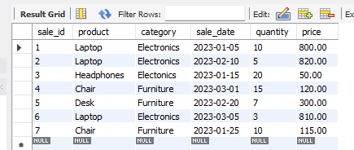

SELECT category, SUM(quantity) AS total_quantity, SUM(quantity*price) AS total_revenue
FROM sales2
GROUP BY category
ORDER BY total_revenue DESC;
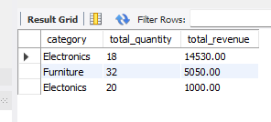
SELECT DATE_FORMAT(sale_date,'%Y-%m') AS month, SUM(quantity) AS total_quantity,
SUM(quantity*price) AS revenue
FROM sales2
WHERE category='Electronics'
GROUP BY month
ORDER BY month;
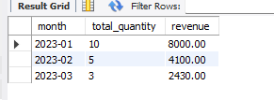
SELECT product,SUM(quantity) AS total_quantity,SUM(quantity*price) AS total_revenue
FROM sales2
GROUP BY product
ORDER BY total_revenue DESC
LIMIT 3;
